CRM Application for Jewel Management - (Developer)

College Name : Tiruppur Kumaran College For Women

College Code : bru3j  
  
TEAM ID : NM2025TMID28422  
TEAM MEMBERS ;  
 Team LeaderName : Afna Fathima   
 Email: [afna3007@gmail.com](mailto:afna3007@gmail.com)

Team Member : THARANI G  
 Email: dharaniganesan357@gmail.com

Team Member : VAISHNAVI N  
 Email : s99967075@gmail.com

Team Member : RAHANA S  
 Email : anishf805@gmail.com

**INTRODUCTION**

**PROJECT OVERVIEW** The **Jewel Inventory CRM Application** is a Salesforce-based solution designed to simplify and automate the management of jewellery inventory and customer relationships. It provides jewellery retailers and manufacturers with a centralized platform to manage stock levels, track customer interactions, streamline sales processes, and maintain accurate transaction records. With features like automation, reporting, and alerts, the application ensures efficient inventory control, enhanced customer engagement, and improved business decision-making.  
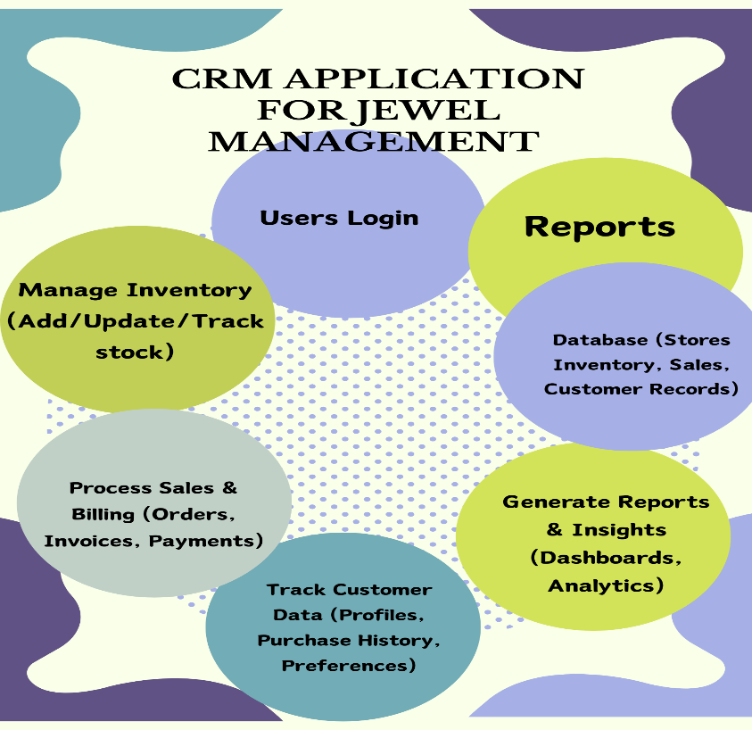

**Purpose**

The main objective of the CRM application is to help jewellery businesses efficiently manage their inventory, customers, and sales operations. It minimizes manual effort by automating key processes such as stock tracking, billing, and customer communication. The system ensures accuracy in maintaining jewellery records, enhances customer engagement through personalized service, and provides managers with insightful reports for informed decision-making. By integrating inventory management with customer relationship management, the application supports smooth business operations, better compliance, and improved profitability.

**DEVELOPMENT PHASE**

Creating Developer Account :

1. By using this URL - <https://developer.salesforce.com/sig>

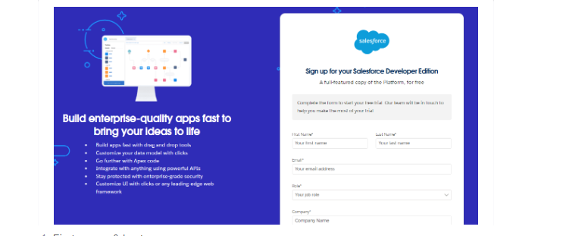

Create Jewel Customer Object:  
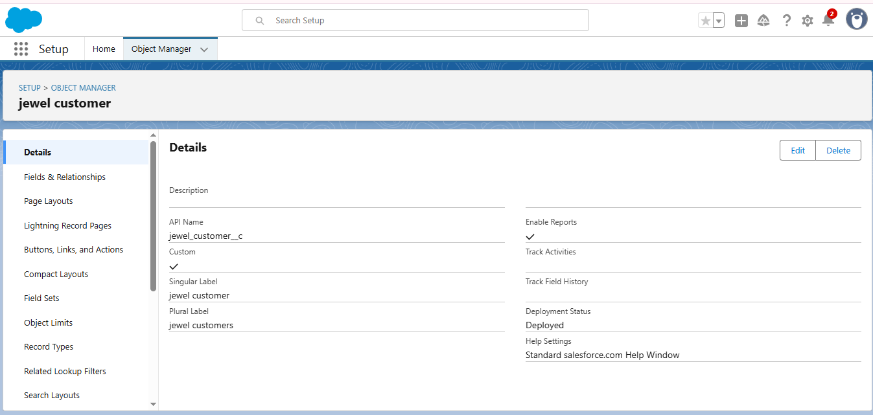

Create Item Object:

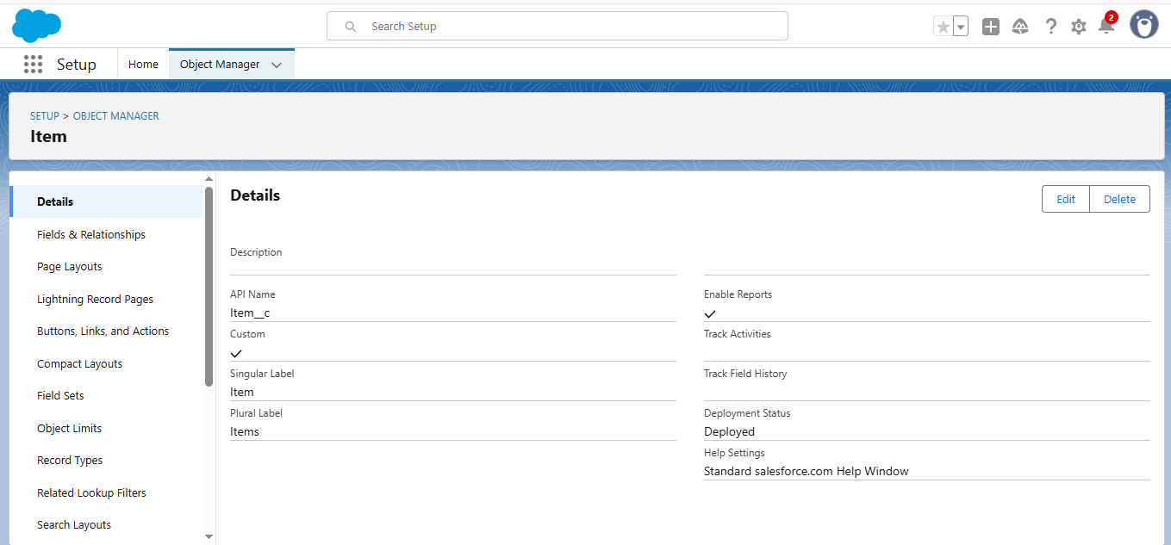

Create a custom Tabs:  
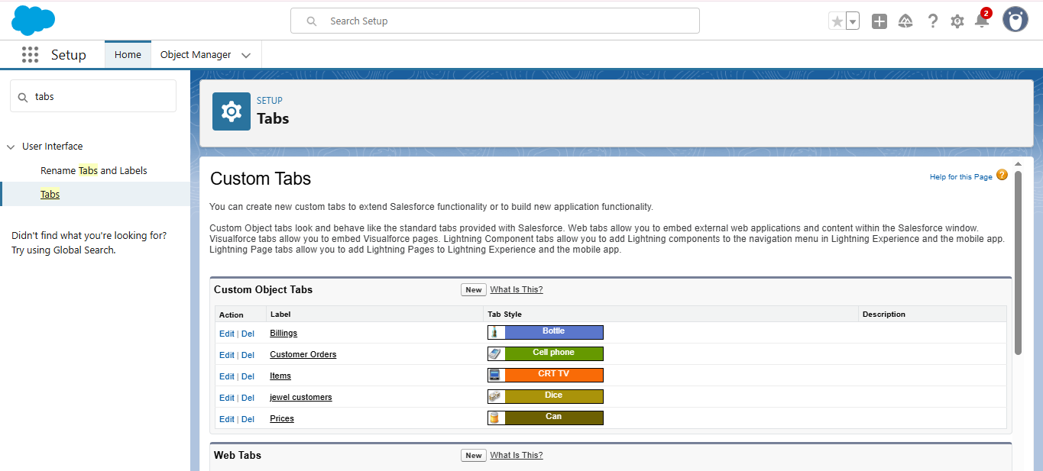

Create a Lightening App:  
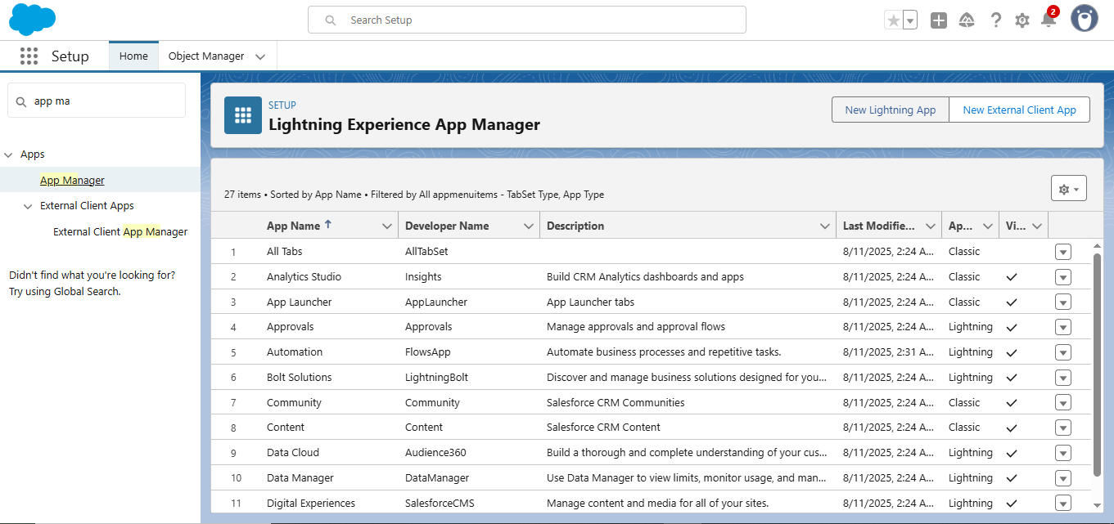   
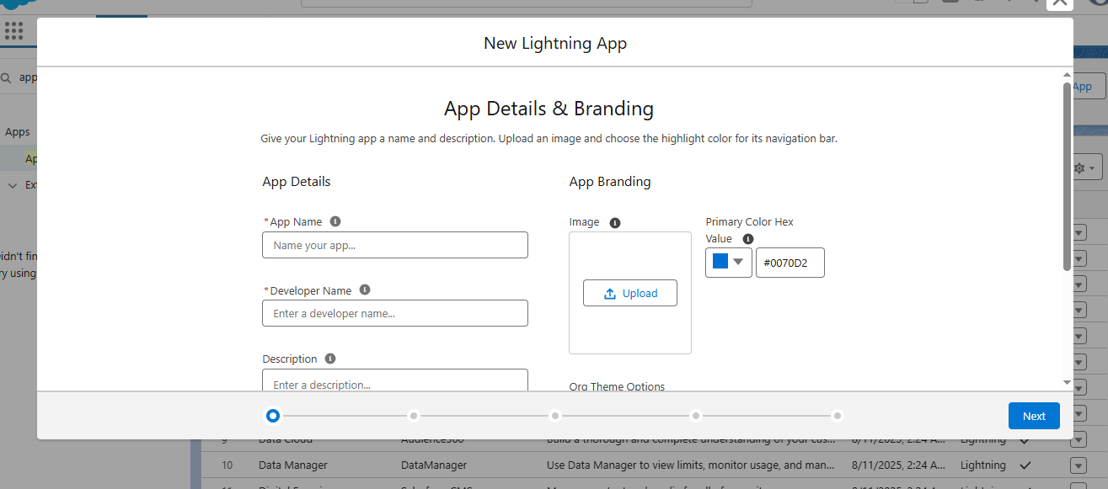

## Fields: Creating Lookup Relationship: between Jewel Customer & Customer Order Objects.

#### Creating a Masterdetail Relationship: Creating Text Field in Jewel Customer Object:

Create The Phone Field in Object jewel Customer:  
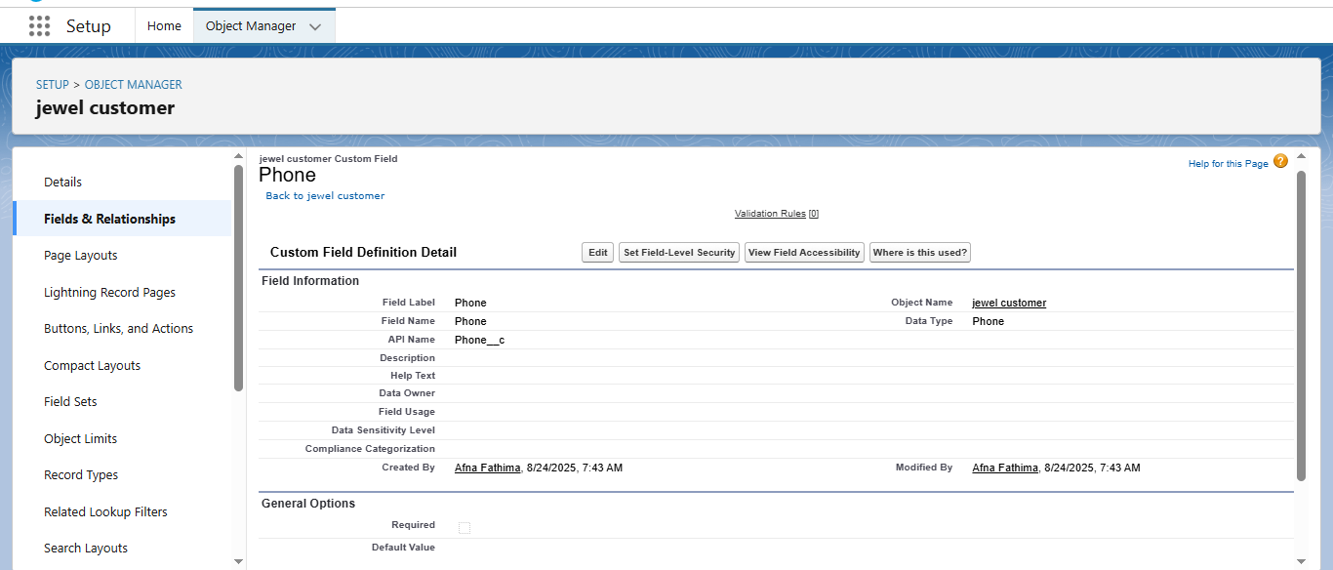  
Create The Email Field In Object Jewel Customer:

### Create The Number Field In Object Jewel Customer: Creating Currency Field in Price Object:

Create The Remaining Fields :  
Create The Validation Rule :  
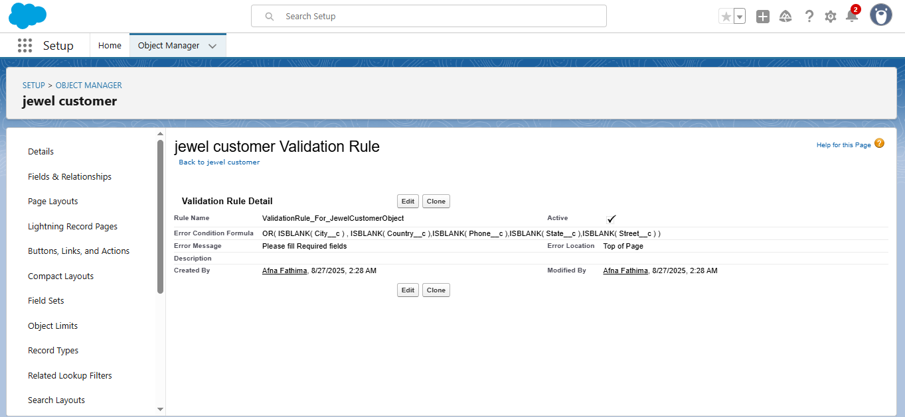

GoldSmith Profile :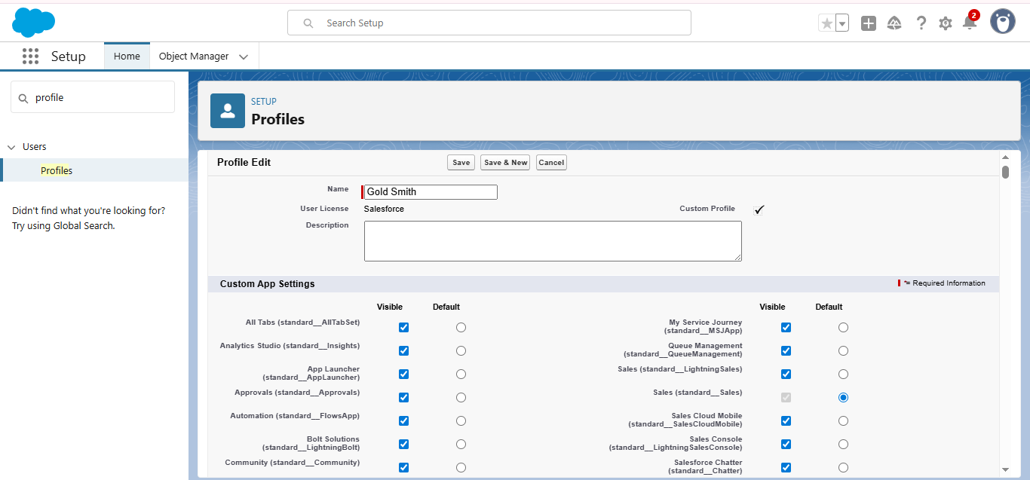   
Worker Profile :  
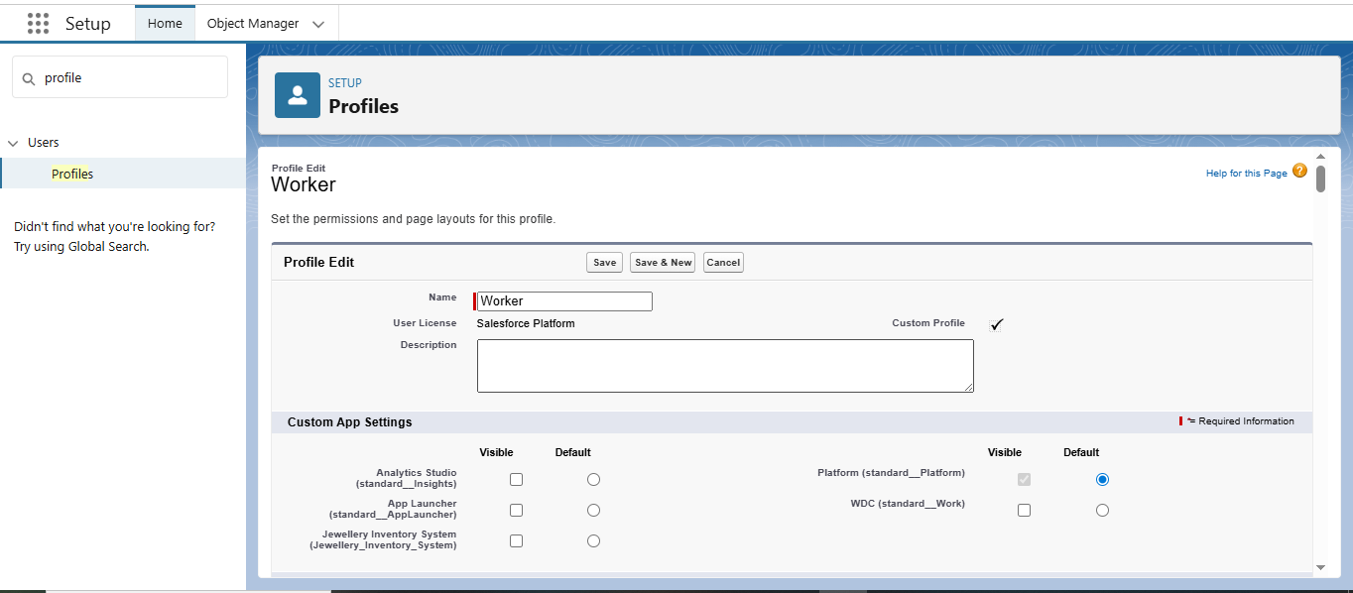   
  
Creating Gold Smith Role :  
  
  
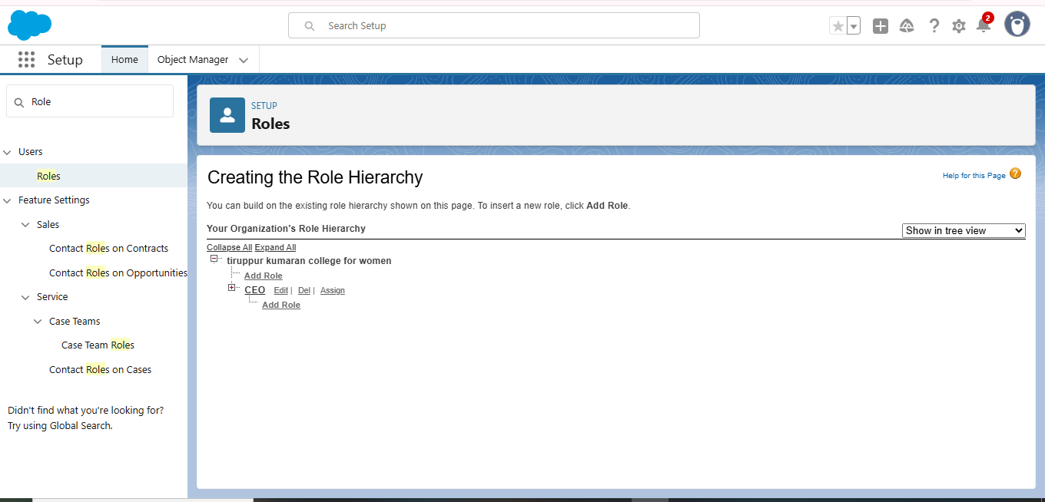   
Create one more role as Worker which reports to Gold Smith.  
create user:  
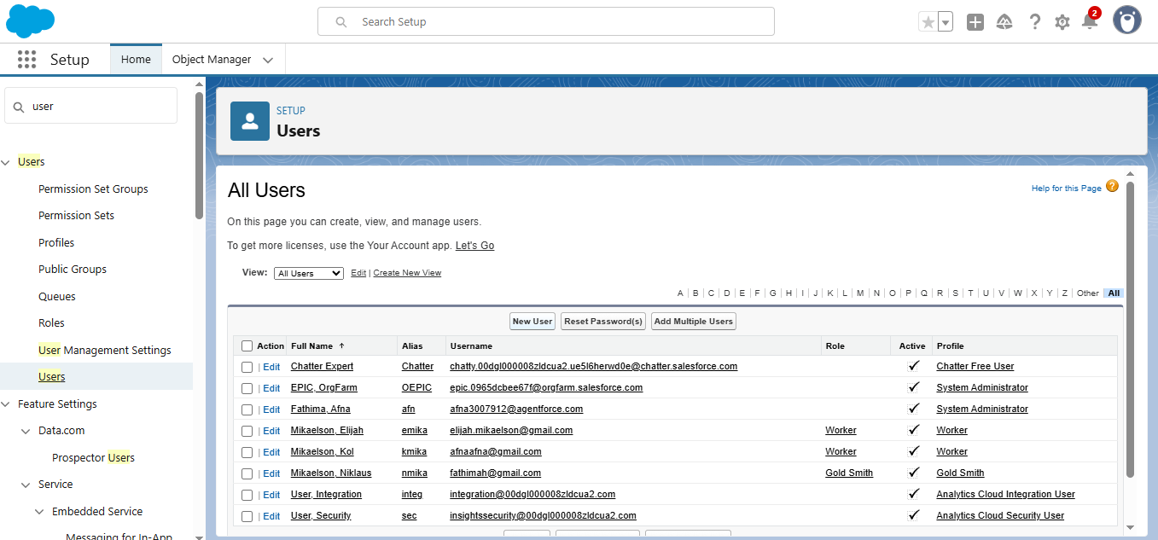  
To Create a Gold Page Layout :  
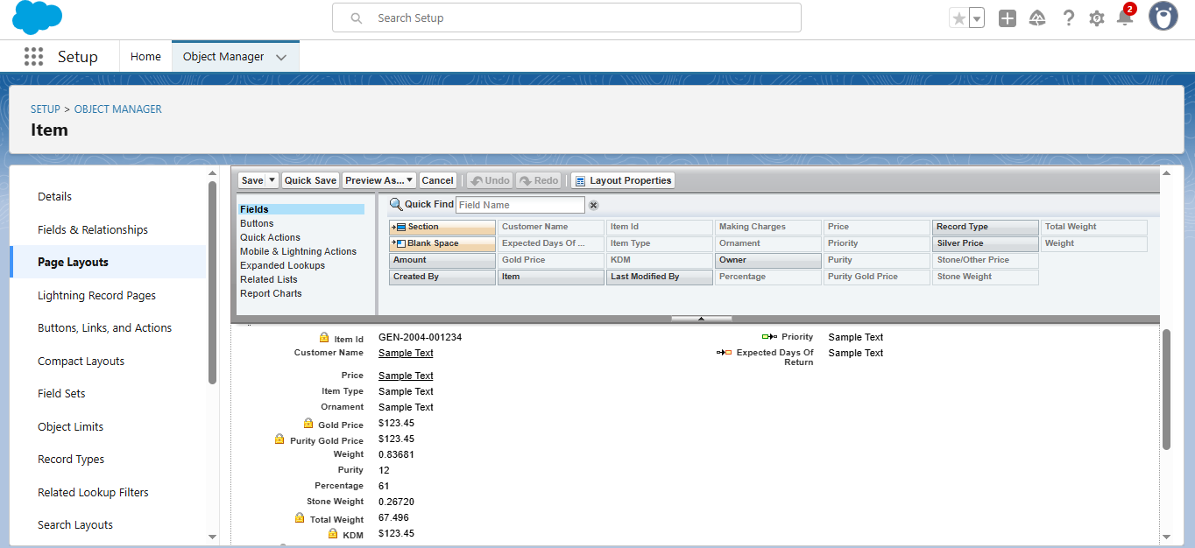   
To Create Silver Page Layout :  
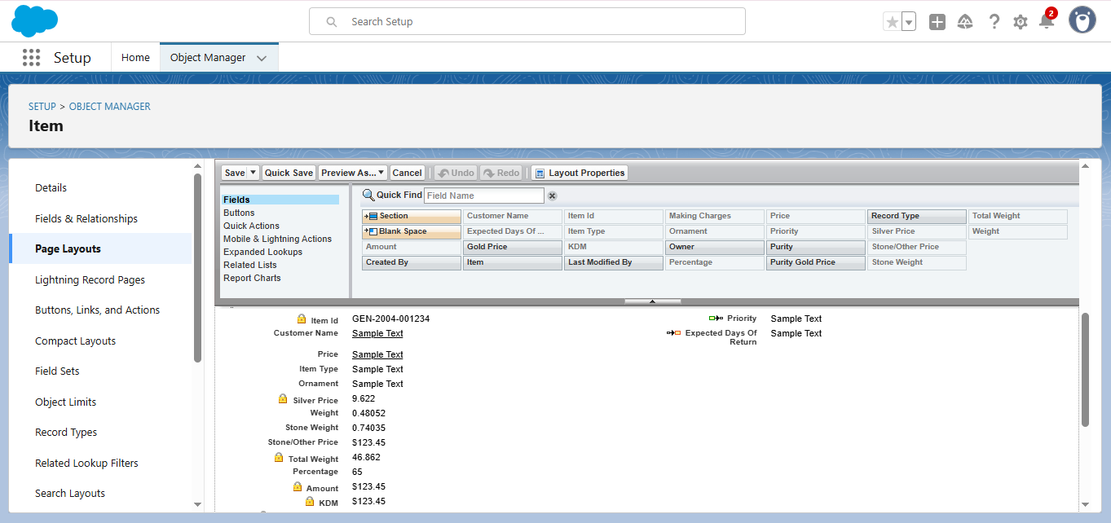  
To Create a Record Type:  
Record Type for Gold :  
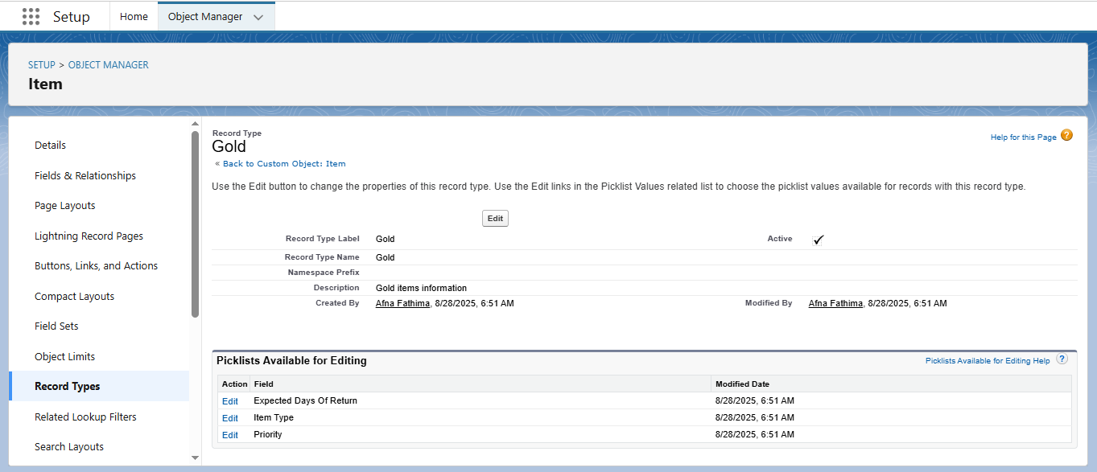  
Record Type for Silver :  
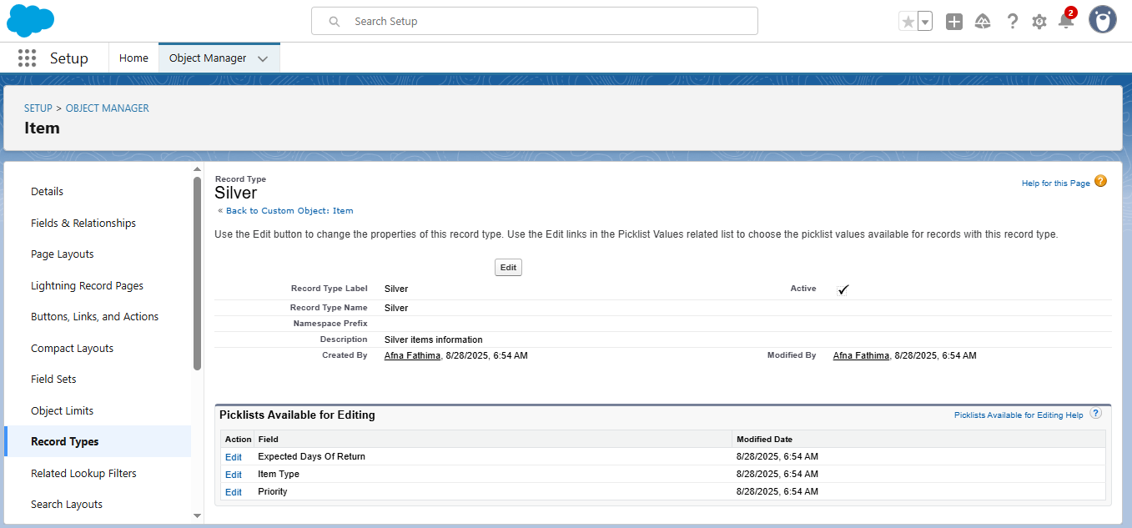  
Create Permission Set :  
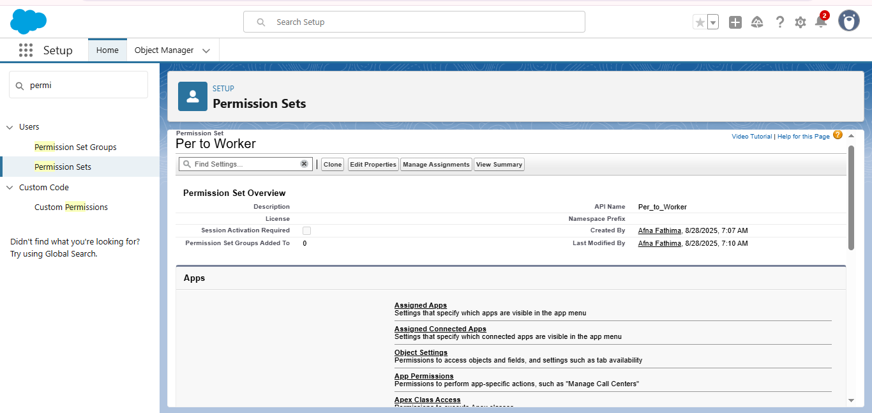  
create a Trigger Handler class:  
public class UpdatePaidAmountTriggerHandler {

    public static void handleBeforeInsert(List<Billing__c> newBillings) {

        for (Billing__c billing : newBillings) {

            billing.Paid_Amount__c = billing.Paying_Amount__c;

        }

    }

    public static void handleBeforeUpdate(Map<Id, Billing__c> oldBillingsMap, List<Billing__c> updatedBillings) {

        for (Billing__c billing : updatedBillings) {

            Billing__c oldBilling = oldBillingsMap.get(billing.Id);

            Decimal oldPaidAmount = oldBilling.Paid_Amount__c;

            billing.Paid_Amount__c = oldPaidAmount + billing.Paying_Amount__c;

        }

    }

}   
  
Create a Trigger :  
trigger UpdatePaidAmountTrigger on Billing__c (before insert, before update) {

    if (Trigger.isInsert) {

        UpdatePaidAmountTriggerHandler.handleBeforeInsert(Trigger.new);

    } else if (Trigger.isUpdate) {

        UpdatePaidAmountTriggerHandler.handleBeforeUpdate(Trigger.oldMap, Trigger.new);

    }

}

**User Adaptation :  
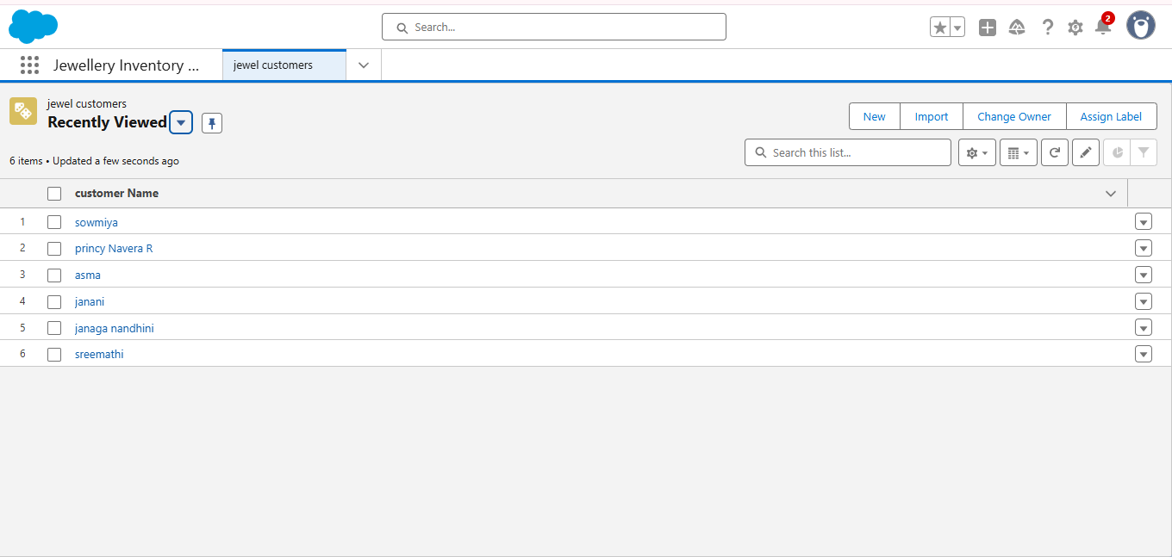**

### View a Record : delete a Record : Reports : Dashboard :

### Flow:

### Conclusion : The Jewel Inventory CRM Application provides a comprehensive solution for jewellery businesses to effectively manage their inventory, customers, and sales operations within a single platform. By integrating inventory control with customer relationship management, the system reduces manual workload, improves accuracy, and enhances customer satisfaction through personalized services. Its automation features, reporting tools, and centralized database enable businesses to make informed decisions and achieve better efficiency. Overall, the application helps jewellery retailers and manufacturers streamline operations, strengthen customer relationships, and improve profitability.